**Two pointers**

lincode：31 partition array

373 partition array by odd and even

144 interleaving positive and negative numbers

49 sort letters by case(daxiaoxie)

leetcode：75 sort color

lincode: 143 sort colorII (rainbow)

leetcode: 1 two sum

add up to

return indices

***exactly*** one solution

not use the *same* element twice.

Given an array of integers

Unsorted---hash map

No duplicate – easier

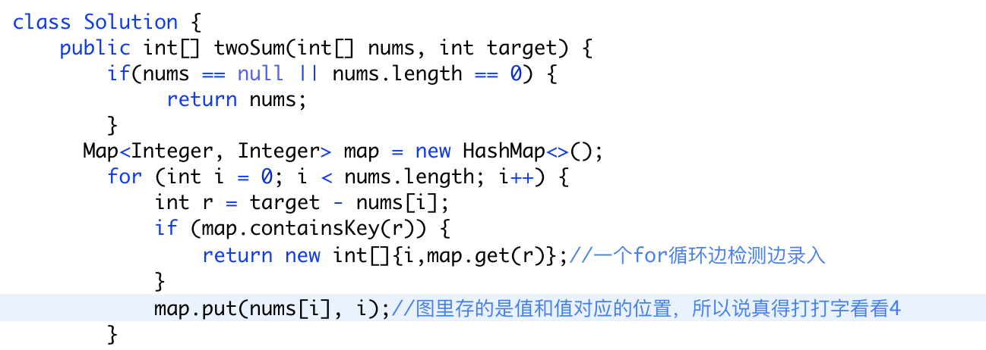

**167. Two Sum II - Input array is sorted**

already *sorted in ascending order*

Your returned answers (both index1 and index2) are not zero-based.

*exactly* one solution

not use the *sa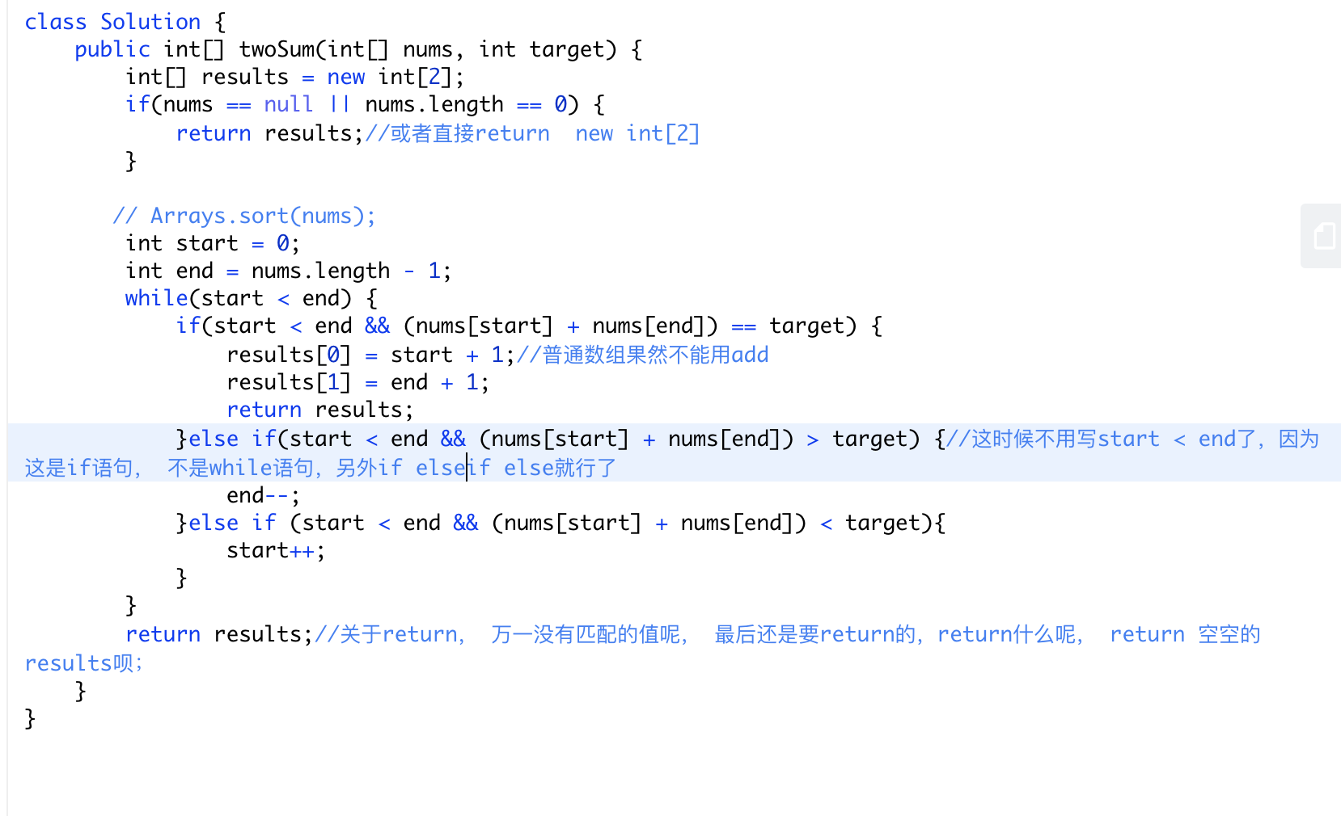me* element twice.

*lintcode***Two Sum unique pairs**

**Duplicates**

**Unsorted**

**Return numbers of answers**

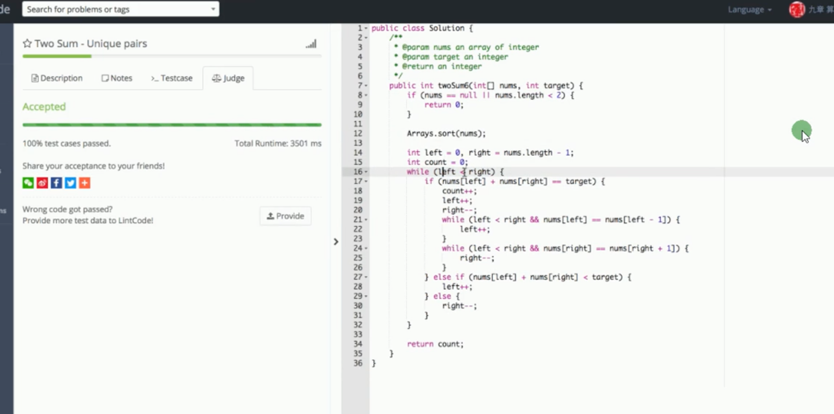

*Lintcode 607 two sum III – Data structure design(170 (locked)(leetcode)*

 internal data structure

duplicates

unsorted

return boolean

不返回当前坐标就能sort之后双指针，不sort之后map，若要返回当前坐标只能map，

包含duplicates而且需要unique表示出来就写while

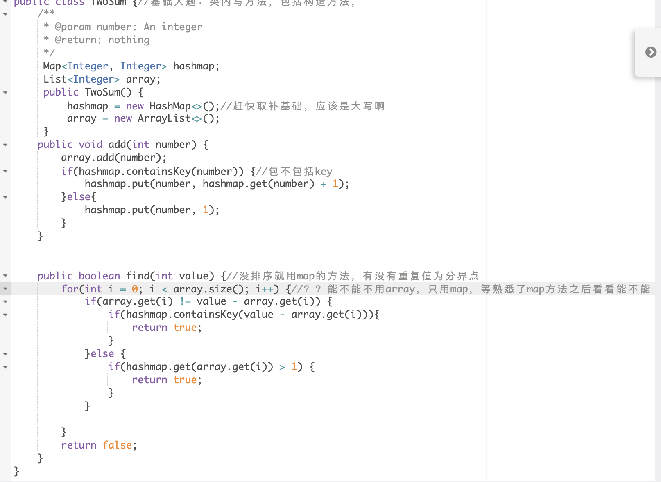

**15. 3Sum**

The solution set must not contain duplicate triplets.

O(n^2) O(1)

也可以map O(n^2）O(n)

